**ANY impartial game can be transformed into a Nim game using Sprague-Grundy Theorem.**

In [combinatorial game theory](https://en.wikipedia.org/wiki/Combinatorial_game_theory), an **impartial game** is a [game](https://en.wikipedia.org/wiki/Mathematical_game) in which the allowable moves depend only on the position and not on which of the two players is currently moving, and where the payoffs are symmetric. In other words, the only difference between player 1 and player 2 is that player 1 goes first.

**Nim Game**

Any position where the [xor](http://www.xcprod.com/titan/XCSB-DOC/binary_xor.html" \t "_blank) value of all piles is not zero is a winning position, otherwise it is a losing position. This xor value usually refered as *nim-sum*.

**মিজেরা(Misere) নিম**

**Misere** একটা ফ্রেঞ্চ শব্দ। মিজেরা নিমগেম এ যে খেলোয়ার শেষ পাথরটা তুলে নিবে সে হেরে যাবে। মিজেরা নিম এও xorsum>0xorsum>0 উইনিং পজিশন। তবে প্রথম খেলোয়াড়কে স্ট্রাটেজি কিছুটা পরিবর্তন করতে হবে। শেষ চালে সবগুলো পাথর তুলে না নিয়ে একটা মাত্র পাথর রেখে দিতে হবে, দ্বিতীয় খেলোয়াড় তখন শেষ পাথরটা তুলতে বাধ্য হবে। তবে যদি প্রতিটা স্তুপেই ঠিক ১টা করে পাথর থাকে তখন আর xorsum দিয়ে কাজ হবে না। তখন দেখতে হবে স্তুপের সংখ্যা জোড় নাকি বেজোড়। যদি বেজোড় সংখ্যা স্তুপ থাকে এবং প্রতিটাতে ১টা করে পাথর থাকে তাহলে বর্তমান খেলোয়াড়কে হারানো সম্ভব না।

**Nim With Skip Move**

Given the original nim game with extra rule

* Skip turn: A player is allowed to say I will skip turn
* Player 1 is allowed up to A skippings
* Player 2 is allowed up to B skippings
* Given the N piles, A, B who is the winner?
* If A = B? Then whoever the winner can cancel the other player move to insure winning (Move Cancellation)
* If A > B and 1st wins in normal nim, then he just plays normally and cancels moves for 2nd if he skipped
* If A > B and 1st loses in normal nim, then he skip the first time, and then play as previous case to win too :)
* So if A > B, 1st always win. If A < B, 2nd always win.

**প্রাইম পাওয়ার গেম**

একটা সংখ্যা n দেয়া আছে। একজন খেলোয়াড় তার চালে nn কে কোনো একটা প্রাইম সংখ্যার পাওয়ার দিয়ে ভাগ করতে পারে। সংখ্যাটা যদি ১ হয়ে যায় তাহলে বর্তমান খেলোয়াড় জিতে যাবে।

লক্ষ্য করো যেকোনো সংখ্যা n কে কিছু প্রাইম সংখ্যারগুণফল হিসাবে লেখা যায়। যেমন n=56700 হলে আমরা লিখতে পারি n=(2×2)×(3×3×3×3)×(5×5)×(7)=2^2×3^4×5^2×7^1

n=(2×2)×(3×3×3×3)×(5×5)×(7)

এখন তুমি মনে করে ৪টা পাথরের স্তুপ আছে, এবং পাথরের সংখ্যার সেট {2,4,2,1}{2,4,2,1}। এখন এটা নিম গেম এ পরিণত হয়েছে, তুমি যেকোনো একটা স্তুপ থেকে এক বা একাধিক পাথর তুলে নিতে পারো!

**Dividing a number**

Given an integer N

* Move: divide N by a prime power > 1
  + e.g. 3, 3^2, 3^3…
  + primes: 2, 3, 5, 7, 11….
* Loser: N = 1
* Solution: Represent N using its prime powers
* Then we have k piles, each has ai stones
* N = 1440600 = 2\*2\*2\*3\*5\*5\*7\*7\*7\*7
* So piles are = {3, 1, 2, 4}
  + E.g. we have 4 7s

**Staircase Nim**

* Staircase with n steps, each step has some coins
* Move: move some coins to the left step (except first step)
* 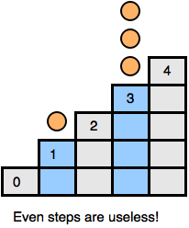Loser: Can’t make a move (e.g. all coins at arr[0])
* Movement from step 1 to step 0 => remove action
* If opponent moved 5 coins from step 2 to step 1, you can just move them to step 0, hence removed them too
* Recall: this is move cancellation strategy
* In general, movements on even position are useless
* Movements from odd position to even can then be considered as removed, but affect game status
* **Solution**: xor odd positions (the piles)

**Nimble**  
Given a line of squares labeled 0, 1, 2, …. Several coins are placed on some squares (it’s possible to have more than one coin on a single square). Two players take turns. One move consists of taking any one coin and moving it to any square to the left of it. It’s possible that the coin moved into a square already containing coins.

**Solution:** This game is exactly a Nim Game where one coin in kth square is a pile of k stones. Moving a coin from kth square to its left is equivalent to removing stones from a pile of k stones in Nim Game.

**Poker Nim**  
This game is played as a standard Nim Game, but players have option to either substracting stones (like in standard Nim Game) or adding more stones in a pile but not exceeding the original number of stones in that pile. To ensure the game termination, each player is allowed to add stones at most *k* (a finite number of) times.

**Solution:** If you already have a winning position in standard Nim Game, then when your opponent adds some stones to a pile, all you have to do is reverse your opponent’s move by removing the exact number of stones he/she added to that pile, thus restoring your winning position. Hence, this kind of game can be viewed as standard Nim Game.

Actually the “not exceeding the original number of stones in that pile” part is not neccesary in this game, one can have the same winning strategy despite of the number of stones added by the opponent.

This type of Nim Game where player can add stones is called **Bogus Nim**.

**Turning Turtle**

* Given a horizontal line of N coins: Head/Tail
  + 1 2 3 4 5 6 7 8 9 10
  + T H T T H H T T T H
* Moves
  + Pick any head, and flip it to tail
  + Optionally, flip any coin on left of your chosen coin
  + Loser: No more heads to flip
  + Action only on Heads. So may be heads ~= Nim piles
  + Head in kth position has k moves. May be Pile size = k
  + E.g. THHTTH => {2, 3, 6} as Nim pile sizes!
* Verification
  + Flip k-th Head only
    - If we did that, we cancelled the k moves from position
    - Seems as if we just removed while pile content!
  + Flip k-th Head and t-th tail (recall k > t)
    - Head at k has k moves cancelled
    - But a tail at is now H and has t moves
    - As if pile of k stones reduced to t stones only
  + Flip k-th Head and t-th head (recall k > t)
    - This is tricky. We already satisfied nim moves
    - Intuition: If this game is nim => this move is not a new case or a useless move

**Twins Game**

Same as Turning Turtles Game, but

* You must flip 2 coins, not optionally
* Then kth position has k-1 move NOT k
* Also, it means we can’t take whole pile move!
  + Actually both previous notes lead to same thing
  + As in terms of nim, pile size = 1 is losing condition
  + So F(n) in this game = **F(n-1) in normal nim**
* So kth position is pile of size n-1
* So THHTTH => {1, 2, 5} NOT {2, 3, 6} sizes
* If you **indexed** game as 0-based, then F(n) = n
  + Sometimes one of the 2 indexings makes computations/patterns easier (later)

**Silver dollar Game**

* Array of N cells, that has coins (at most 1 coin in a cell)
* Move: Pick a coin and move to **any left square: BUT**
  + **Can’t** jump over other coins
  + **Can’t** put two coins in one cell
* Loser: Can’t do a move
* Example. for 4 coins in position {2, 5, 7, 10}
* 1 2 3 4 5 6 7 8 9 10 11  
  **0 1 0 0 1 0 1 0 0 0 1**

**Solution:** From right most pile, skip every second piles, and take the remaining piles as piles in standard Nim Game. For example, coins in position {2, 5, 7, 11} will have piles {1, 2, 1, 3} and if we remove all second piles from the right most, we’ll get {2, 3}.

**Two dimensional Nim**

Two dimensional Nim is played on a quarter-infinite chess-like board with a random finite number of counters on its squares (from now on, all quarter infinite boards will be considered as a board equal to the first quadrant of Cartesian coordinate system, and so it will be infinite in the up and right directions, with solid borders at lower and left side). In one move of the game, a player must move any counter from the board either leftwards or downwards. In the normal type of game, the first player unable to make a move is the loser.

**Solution:** Despite the fact that the game may seem more sophisticated because of one additional dimension, this is only basic nim in disguise. The position of every counter can be specified using two numbers as coordinates. These numbers also indicate the hypothetical size of piles in nim, because of inability to change both coordinates of any counter in one move. For instance, moving one counter to the edge of the board is represented by taking all of the counters from one pile in the game of Nim. Position in Figure 1.6 is then equal to Nim position (1,2,2,3,4,5,7,7).

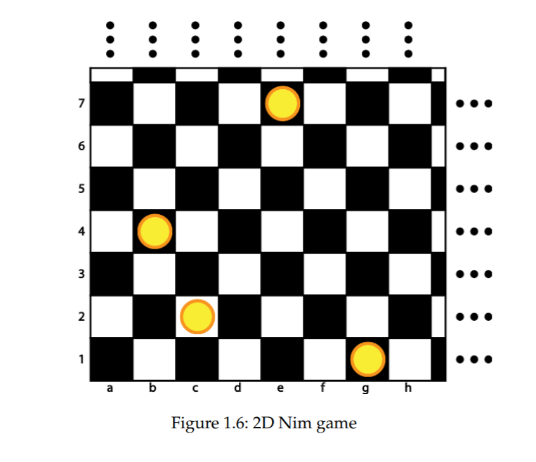

**Wythoff's game**

**Wythoff's game** is a two-player [mathematical](https://en.wikipedia.org/wiki/Mathematics) [game of strategy](https://en.wikipedia.org/wiki/Game_of_strategy), played with two piles of counters. Players take turns removing counters from one or both piles; when removing stones from both piles, the numbers of counters removed from each pile must be equal. The game ends when one person removes the last counter or counters, thus winning.

An equivalent description of the game is that a single [chess queen](https://en.wikipedia.org/wiki/Chess_queen) is placed somewhere on a large grid of squares, and each player can move the queen towards the lower left corner of the grid: south, west, or southwest, any number of steps. The winner is the player who moves the queen into the corner.

**Solution:** Any position in the game can be described by a pair of integers (*n*, *m*) with *n* ≤ *m*, describing the size of both piles in the position or the coordinates of the queen. The strategy of the game revolves around *cold positions* and *hot positions*: in a cold position, the player whose turn it is to move will lose with best play, while in a hot position, the player whose turn it is to move will win with best play. The optimal strategy from a hot position is to move to any reachable cold position.

The classification of positions into hot and cold can be carried out [recursively](https://en.wikipedia.org/wiki/Recursion) with the following three rules:

1. (0,0) is a cold position.
2. Any position from which a cold position can be reached in a single move is a hot position.
3. If every move leads to a hot position, then a position is cold.

For instance, all positions of the form (0, *m*) and (*m*, *m*) with *m* > 0 are hot, by rule 2. However, the position (1,2) is cold, because the only positions that can be reached from it, (0,1), (0,2), and (1,1), are all hot. The cold positions (*n*, *m*) with the smallest values of *n* and *m* are (0, 0), (1, 2), (3, 5), (4, 7),(6,10) and (8, 13).

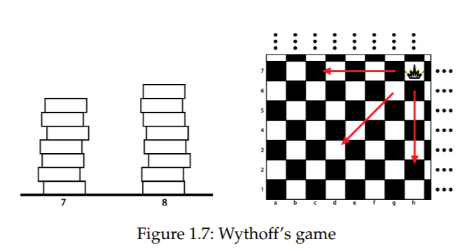

**Green Hackenbush**

This impartial form of Hackenbush is played by two players by deleting branches of graphs. The starting position of the game consists of a finite number of graphs. Every edge of this graph must be either directly or transitively connected to the ground. The game can also be played with borders around the whole playground. The rules for deleting these branches are:

* player must delete one branch of his choice in his move
* after each move, all branches that are no longer transitively connected to a border are deleted as well
* the first player who has no branches left to delete is the loser

**Solution:** We consider it to be green because each edge can be removed by either player. Because we're working with a tree, we can also easily apply the colon principle.

**For tree:** The colon principle states that, if a node is connected with  stalks of length a0, a1,….a(n-1), then all of these stalks can be replaced with a single stalk of length . a0 ^ a1 ^ ….. ^ a(n-1)

When using the colon principle on a tree, we can recursively convert the tree into a stalk. A stalk of length ‘L’ is same as a single Nim pile of height ‘L’. This means that if we end up with a single Nim pile of positive height, 1st wins; otherwise, 2nd wins.

**Red – Blue Hackenbush**

* Until the parity changes for the first time, each number is worth +V or -V (depending on whether it is Blue or Red, respectively).
* Once parity change occurs, each subsequent number (regardless of being Even or Odd), is worth half of the previous value, with a +/- corresponding to the parity

Lets take this pile for example **{4, 8, 9, 11, 16}**. Its value can be calculated as: +V +V -V/2 -V/4 +V/8 = 11V/8

For multiple stalk, don’t xor, just add all of them, if positive blue wins, negative red wins

**Grundy Number**

def grundyNumber (current\_state):

moves[] = possible positions to which I can move from current\_state

set X;

for (all new\_state in moves)

X.insert(grundyNumber(new\_state));

int ret=0;

while (s.contains(ret)) ret++;

#ret is the smallest non-negative integer not in the set s;

return ret;

**Min-Max Algorithm**